
August 2015
Welcome to the
Wessex Mental Health, Dementia and Neurology
Strategic Clinical Network Newsletter
The Mental Health, Dementia and Neurology Strategic Clinical Network is focused on providing clinical expertise and support for service redesign in key areas. We are focused on delivering against national priorities, developing practical tools to improve patient experience and outcomes, tailored to meet local needs.

In all of our projects we work very closely with service commissioners, including Clinical Commissioning Groups (CCGs), Specialised Commissioners and those in Local Authorities, and other local partners such as those in the voluntary sector, Academic Health Science Networks, CLAHRC, Health Education Wessex and Public Health England. This close working has helped us to deliver work that is important, effective and supported throughout Wessex. The SCN has also played an important part in shaping the national agenda and work plans.

Mental Health
It is estimated that one in four people in the UK are affected by mental health problems. Despite this, the quality of mental health services, and the resources available to them, continues to lag behind physical health.

Mental health problems account for 23 per cent of the total impact of ill health in the UK. However, only 13 per cent of the NHS budget is allocated to mental health.

Parity of Esteem (valuing mental and physical health equally) emerged as a dominant theme, with an increasing focus now applied to crisis care. The emphasis for Parity of Esteem has been on projects that improve access to physical health screening in people with serious mental illness.

The Wessex HEALTH (Helping Everyone Achieve Long Term Health) Passport has had significant uptake by the community mental health teams in the west and south of Hampshire. Since October 2014, more than 200 service users have been recruited to this highly successful pilot project and a range of health improvements have been reported, including one patient giving up smoking and losing two stone in weight.
Smoking and Serious Mental Illness (SMI) project

It has been reported nationally that more people with a SMI smoke compared to the general population. Evidence shows that those with an SMI are more likely to be offered smoking advice, however the success rate of smoking cessation interventions in the SMI group were much lower 28% compared to 50% in the general population. The aim of this project, which started in September 2014, is to reduce the variation in the success rate of the stop smoking services between the general population and those accessing the service with a diagnosed SMI.
We have successfully completed the first stage of this project and have found the national picture is mirrored locally: 42% of patient with a diagnosed SMI smoke compared to 17.5% of the general population. We are now engaging with service users to seek their views on how a stop smoking service could work better for them. The project has strong engagement from Public Health Dorset and Live Well Dorset who are the commissioners and providers of health improvement services across Dorset.
Dementia
We are supporting the national target of increasing the diagnosis rate of dementia to 66.7% coupling this with developing methods of providing strong post diagnostic support.

The SCN is working on pathway redesign, collaborating with key partners such as the Bournemouth University Dementia Institute, the Wessex Collaboration for Leadership in Applied Health Research and Care, and Southern Health NHS Foundation Trust (including the Memory Assessment and Research Centre). We have surveyed GPs on their skills, attitudes and barriers to diagnosing dementia and held patient focus groups. The result has been the development of a dementia diagnosis decision support tool which will initially be piloted in care homes. This work has clearly identified the importance of confidence in and capacity of high quality support post diagnosis.
Following from our successful event last year, we are holding our second Dementia Collaboration Conference:
2nd Wessex Dementia Collaboration Conference
Quality care, research and risk reduction in dementia

21st October 2015 : 09:00 - 14:00
St Mary’s Stadium, Southampton, SO14 5FP
This event will include:
- Reducing risk of developing dementia
- Wessex Dementia Timeline launch
- Presentation of awards for Best Projects in Wessex by Alistair Burns
- Carer’s perspective on John’s Campaign
- Workshops to learn how to implement good practice in your area
This is a free event. More details of how to register will follow soon. However, if you would like to register your interest in this event, please reply to england.wessexscn@nhs.net
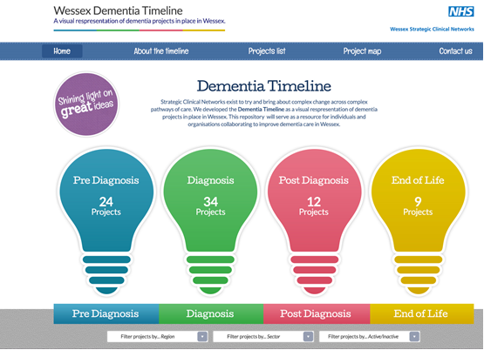

Neurological Conditions
Neurology priorities have focused on improving access to neurological expertise, and the use of data to better inform pathway re-design in neurological services. Over the past year we have:
- commissioned the mapping of Hospital Episode Statistics data on neurological admissions and a review of neurological resources around Wessex to identify areas for future service redesign,
- provided input into the Neurology Intelligence Network through the Expert Reference Group and worked with Public Health England to develop a Neurology Dashboard,
- developed the Huntington’s disease Clinical Co-ordinator role, together with Health Education Wessex, as part of a quality improvement fellowship in partnership with University Hospital Southampton NHS Foundation Trust. (This project also supports our parity of esteem agenda)
- been analysing the kinds of critical events that lead to unscheduled care and delayed discharge from hospital for patients with certain neurological conditions in a project called Critical Events and Risk Stratification in Long-Term Neurological Conditions,
- running a project to develop the requirements, methods, audit and costing of a sustainable neurology Advice and Guidance service. Advice & Guidance pilot currently running in the Portsmouth area, and
- supported the development of HEADMAT™ which is an innovative initiative, which enables the redesign of the treatment pathway for patients presenting in primary care with headaches. The tool has been designed and will be piloted across 19 GP practices.

Our priorities for 2015/16
Our priorities for the Mental Health, Dementia and Neurology SCN for 2015/16 are:
- Supporting the delivery of the Mental Health Access and Waiting Time Standards
- Improve crisis care in mental health and continue work on parity of esteem.
- Support the national ambition to reach a 66.7 per cent dementia diagnosis rate, while also supporting effective services post diagnosis including for those in care homes.
- Support improvements in meeting neurological standards and access to neurological expertise.

FEEDBACK
We’d love to know what you think of the newsletter and the links it contains. Please click HERE to send us your comments and ideas.

For further information please contact england.wessexscn@nhs.net

